**Software Requirement Specification (SRS)**

**Kareem Abdelaziz 211009483**

**Lujain Ezzat 211009271**

**Ahmed Reda 211002981**

**Supervised by: Dr. Mohamad Eltaweel**

**Eng. Amr Daba**

**(I) Website name and description:**

**(A) Website Name:** ELECTRON

**(B) Description of website:** Electron is a leading e-commerce website offering an online platform for IT computer components, consumer electronics, and anything needed in electronic components.

**(C) Users’ characteristics:**

**1 – User:**

- Registers themselves on the website to start buying products

- User can browse to purchase a specific product or multiple products available on the website

**2 – Admin:**

- Monitors all product information, site issues and resolves them

- Updating content in case of site-wide promotions

- Creates backups of the website

- Manipulate the database and employee accounts

**(II) Database ERD:**

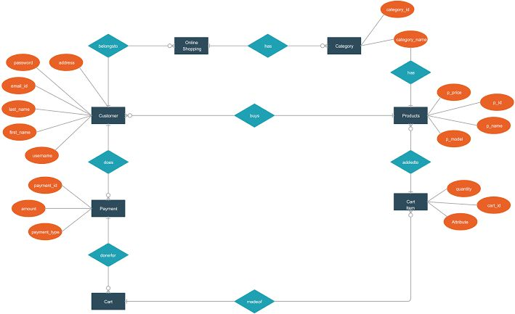

**(III) Use Case Diagram:**

**(IV) Functional Requirements:**

**(A) Users:**

**1. Register:**

- Allows user to register an account.

- Inputs: username, email, password, confirm password.

- Output: create a user account.

**2. Login:**

- Allows user to enter their email and password to access their profile.

- Inputs: email and password.

- Outputs: users open their profile.

**3. Add to cart:**

- Adds item selected to the cart.

- Inputs: Item-id, Item-name.

- Outputs: products are added to the user’s cart.

**4. Remove from cart:**

- Removes item selected from the cart.

- Inputs: Item-id, Item-name.

- Outputs: Selected items removed from the cart and total are updated.

**5. View category:**

- Users view all products under the same category.

- Inputs: Category-name.

- Outputs: Show all products of the chosen category.

**(B) Admin:**

**1.Add item/Product:**

- Uploads items to the websites.

- Inputs: Product-id, Product-name, Product-description, price.

- Outputs: Item is added to the website.

**2.Delete item/Product:**

- Removes items from the website.

- Inputs: Product-id, Product-name, Product-description, price.

-Outputs: Items is removed from the website.

**3.Update item/Product:**

- Update info of existing products.

- Inputs: Product-Description, Price.

- Outputs: products info is updated.

**(V) Website’s main pages:**

**1.Home Page:**

- Landing Page when a user visits the website.

**2. Login / Register Page:**

- Login/Register page is where the user logins into his account if he’s an existing user or where the user will register for the first time if he doesn’t have an account.

**3.Cart Page:**

- Cart Page is where the cart will be displayed for the user with the products he added to the cart.

**4.Checkout Page:**

- Checkout Page is where a user will finalize his cart and checkout.

**5.Contact Us Page:**

- Contact Us Page is where a user or a vendor can send an inquiry.

**6.Product Page:**

- Product Page is the page displaying the product’s picture and description about the product and a button if the user wants to add it to the cart

**7.Category Page:**

- Category Page is a page that displays all the products that match the category chosen by the user

**(VI) GitHub Accounts:**

**Kareem:**

**Lujain:**

**Ahmed:**